Remote Flight Controller User Guide

Contents
Form Design & Prefix 2
How to use the remote flight simulator 3
Connecting to the flight simulator 3
The simulation 3
Integrating Remote Flight Controller class to another project 5
Delegates 5
Register delegate instances with event 6
Events 7
Threads 9
Listener Thread 10
Updating track bar thread 11
JavaScript Object Notation (JSON) 13
Integrating JSON 13
References 15

Form Design & Prefix

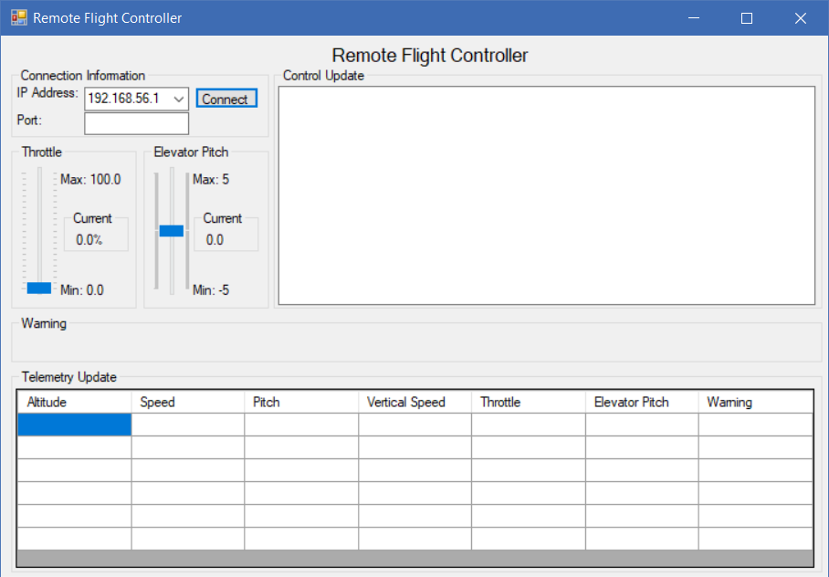
This is the design of the Remote Flight Simulator program
Prefix used
Text box = txt
Label = lbl
Button = btn
Form = frm
Group box = grp
Trackbar = trk
Data grid view = dgv

How to use the remote flight simulator

Connecting to the flight simulator
To connect to the flight simulator. The flight simulator must be listening to connections. To do this you must first specify the IP and port details then you must click the open port button on the flight simulator.

To connect to the flight simulator from the remote flight controller you will have to specify your IP address using the IP address combo box. If the IP address you are looking is not in the list, you can type it into the combo box. You will have to specify the port you are trying to connect to. To do this you must type in the port number you are trying to connect to. After you connect you should see this dialog:
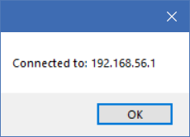
This confirms that you are now connected to the Flight Simulator.
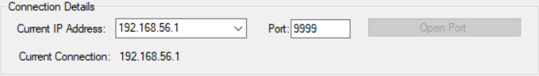
The Flight simulator now also shows that its connected

The simulation
To begin the simulation, click the start simulation button on the flight simulator. When the simulation has started you will start to receive telemetry updates from the flight simulator
This is when the simulation is running the telemetry updates in the table go from the newest data (top of the table) to the older data (bottom of the table). In the telemetry displays the new data from the flight simulator every 0.2 seconds. In the current scenario the plane is flying normally without any error messages being displayed.
To remotely control the throttle and elevator pitch of the flight simulator you must use the throttle and elevator trackbars. And when the throttle and elevator pitch on the flight simulator is adjusted they will also be adjusted in the remote flight controller.
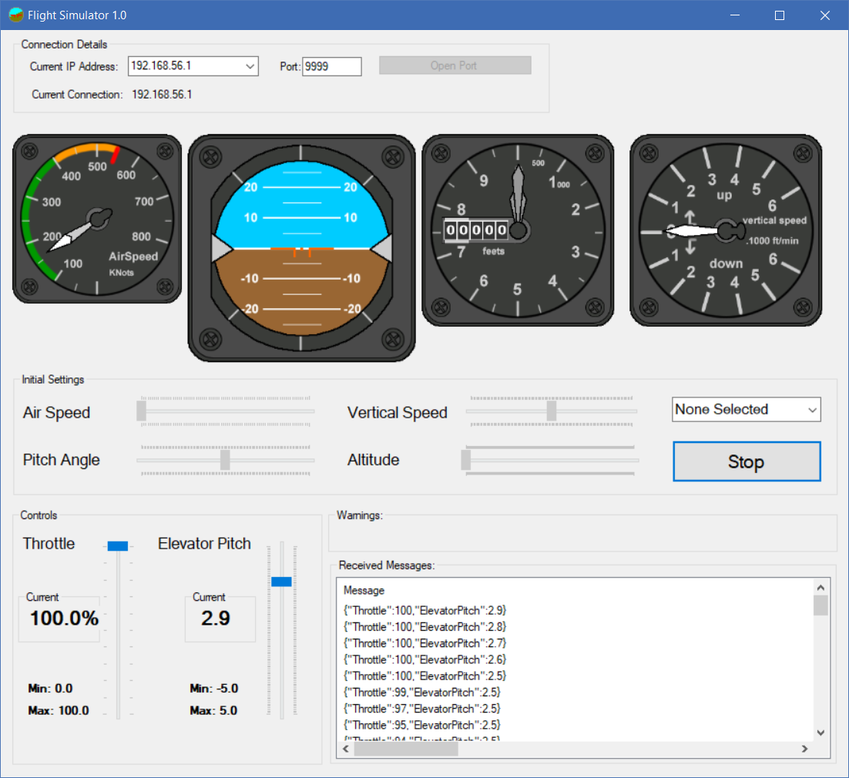
When the Flight Simulator starts to receive the data from the Remote Flight Controller the received data can be viewed in the flight simulator Received Messages text box.
When warnings are received there will be clear instructions on how to correct the warning.

Integrating Remote Flight Controller class to another project

Delegates

Before we can start using delegates well have to define the RemoteFlightController class. Which will be used to trigger events when an event is invoked in the RemoteFlightController class.
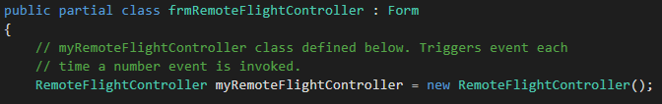
In C# a delegate is a reference to a method which allows objects to be sent as parameters into methods. When defining a delegate, the user of the Remote Flight Controller class can assign any method to that delegate that matches signature and method will be called each time the delegate is called. Delegates will be the first part in integrating the Remote Flight Controller to another class.
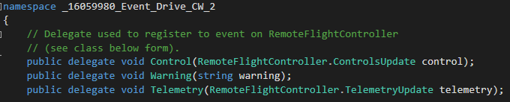
The signature of the Control delegate is that the method must not have a return value and it should have a parameter that allows ControlsUpdate object.
The signature for the Warning delegate it that must not have a return value and it should have a parameter that allows a string.
The signature for the Telemetry delegate it that must not have a return value and it should have a parameter that allows a TelemetryUpdate object.

Register delegate instances with event

We will have to create an instance of a delegate and register. In the context of registering a delegate to an event, the delegate method has many names e.g. Call Back Function, Target and Event Handler.
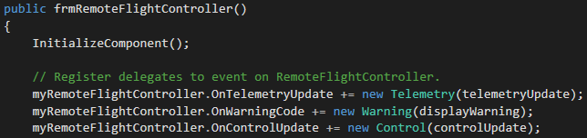
When creating an instance of a delegate and register we must make sure the function to be registered has the same signature as the delegate e.g. the Telemetry delegate registers telemetryUpdate method so we expect the telemetryUpdate method to not have a return value and it should have a parameter that allows a TelemetryUpdate object.
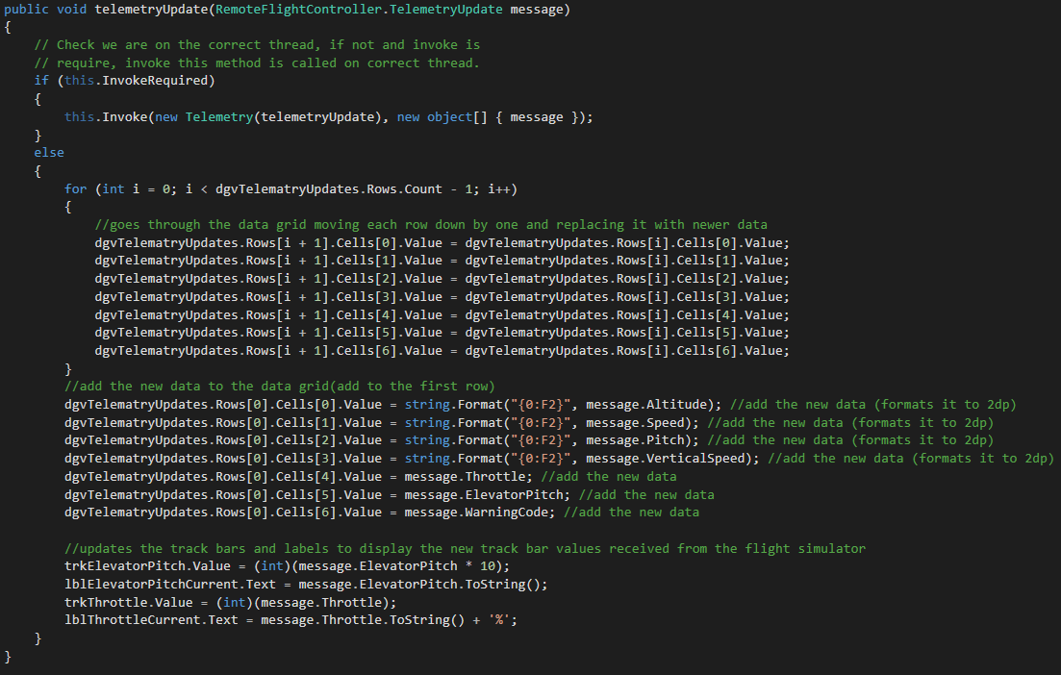
The screenshot above shows that the telemetryUpdate method has the same signature as the delegate because it does not have a return value and it has a parameter that allows a string.

Events

In C# an event enables a class or objects to notify other classes or objects if something of interest happens. The publisher (Remote Flight Controller) determines when an event is raised, the subscribers (class that will handle the event) will determine what action is taken in response to the event. An event can have multiple subscribers. A subscriber can handle multiple events from multiple publishers. Events that have not subscribers are never raised. Events are typically used to signal user actions such as button clicks or menu selections in GUI.
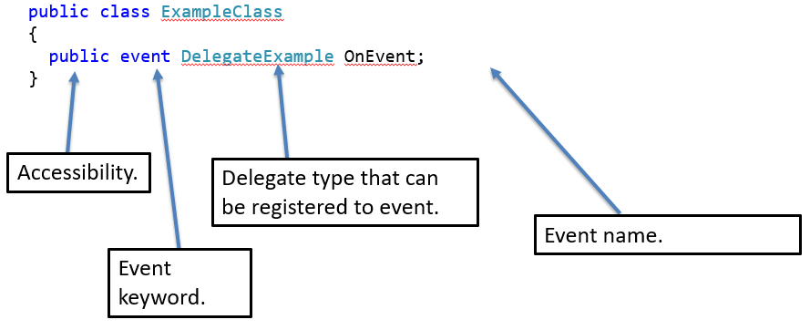
This is the format in which events are declared.
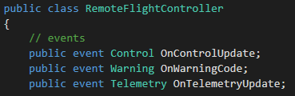
These are the events declared in the Remote Flight Class. The control event sends an object that corresponds to its name e.g. OnControlUpdate event will send control object.
When the OnWarningCode event is invoked. It will send a string to display on the form.
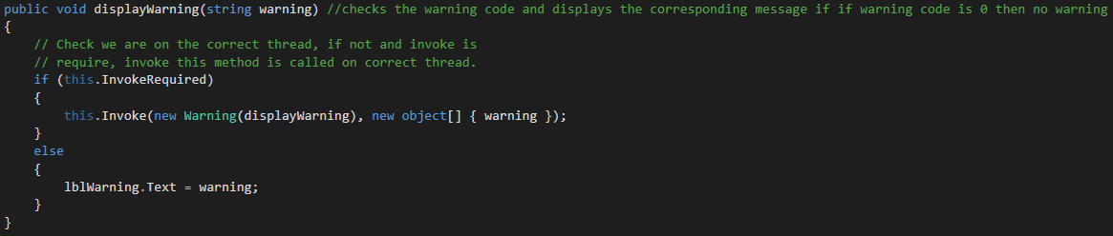

When the OnTelmetryUpdate event is invoked it will send an object to the telemetryUpdate method to update the telemetry text box with the newest telemetry data.
This is how the events are invoked:
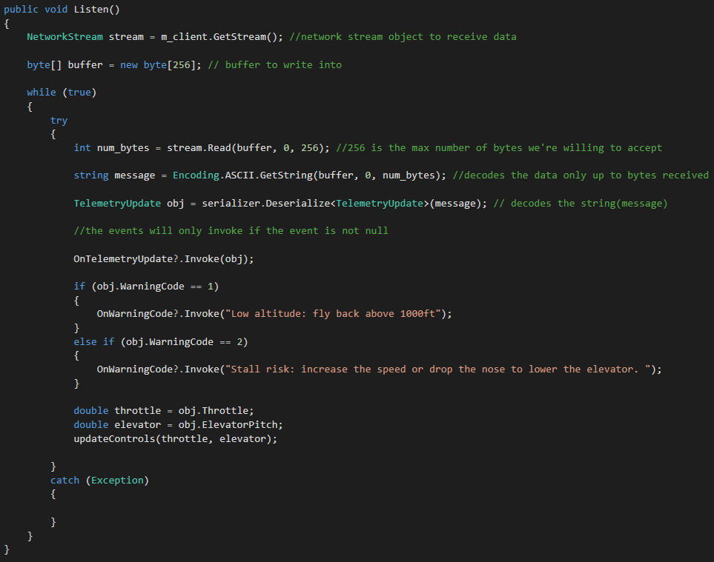
In the example above when an event is invoked e.g. OnTelemetryUpdate?.invoke(obj); OnTelemetryUpdate is the name of the event to be invoked. The ? checks that the event is not null, the .invoke(obj) passes the object to the method registered to the delegate.

Threads

Threads are used to complete large tasks quickly by splitting the task across multiple treads. By using threads, we can pass off complicated tasks to worker threads instead of allowing them to block the main UI interface. We can allow worker threads to handle actions/events/data that don’t happen at the same time. However, if we have too many threads the program can be slowed down. Also, some problems are not easily solved in parallel.
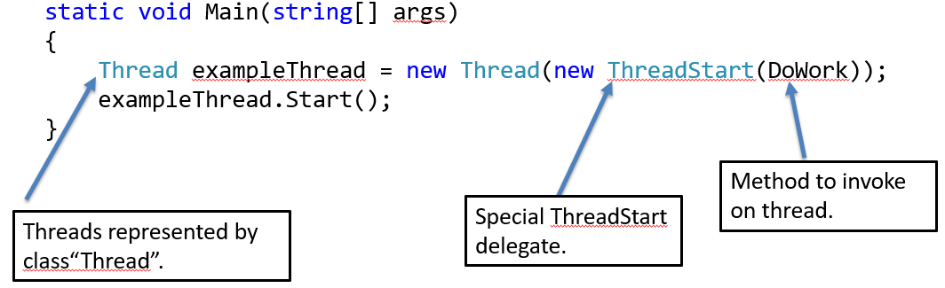

The example above shows how to create threads in c#.
In the RemoteFlightController class a listening thread is used. The listening thread is set to null because we declare other threads and when those threads are done they are, we will assign them to listeningThread so that it can be destroyed.
This is the declaration of the listeningThread

Listener Thread

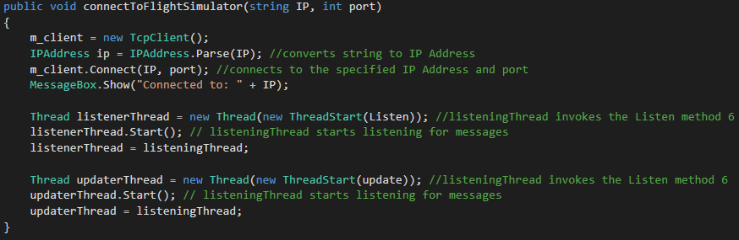
When the connection to the flight simulator is made. The listenerThread invokes the Listen method and when the thread is started the Listen method will start listening for messages from the flight simulator in the background. This is useful because we still want to be able to use GUI while listening to messages.
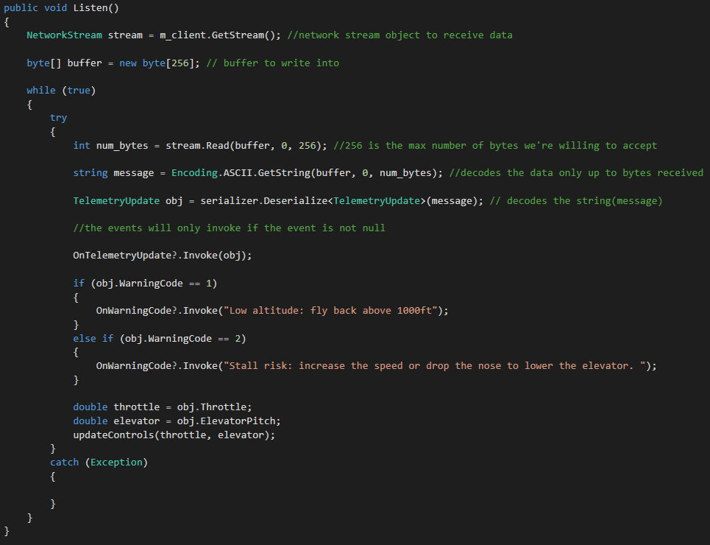
This is the Listen() method, it’s an infinite loop (because we want to always listen for messages).

Updating track bar thread
When a connection is made to the flight simulator the updaterThread is invoked. The updaterThread will start to send and listen to control data.
When telemetry updates are received from the flight simulator the updateControls method is run. When it is run it updates the track bars on the remote flight controller with the data received from the flight simulator.
Also, the updateControls is run when the track bars on the remote flight simulator is moved
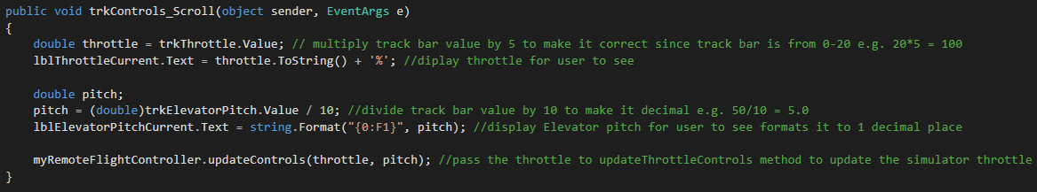
When the track bars on the remote flight controller are moved they send the throttle and pitch values to a method called updateControls.
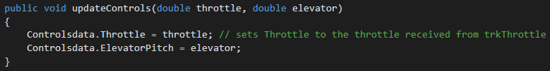
In this method the throttle and pitch will be set to the Controlsdata object.
The updater thread will then be constantly updating all data and updating the trackbars in both programs.
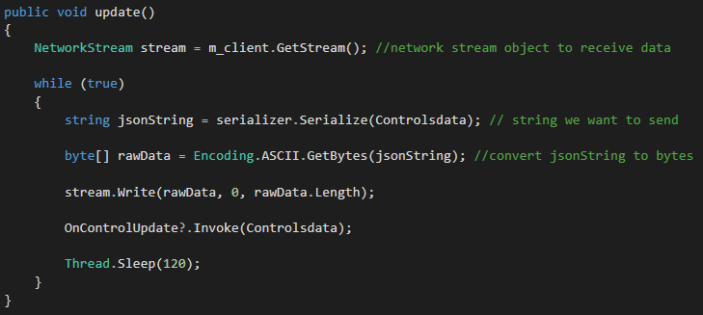
The thread is put to sleep (120 milliseconds) because it would send too much data to the flight simulator if it wasn’t, resulting in the flight simulator crashing from receiving too much data. The reason it’s put to sleep for 120 milliseconds is that it is short enough to make it look real time yet long enough to not send too much data resulting in the simulator crashing.

JavaScript Object Notation (JSON)

When exchanging data between a browser and a server, the data can only be text(JSON). JSON is text and we convert any JavaScript object into JSON and send to the server. JSON is a data format that is designed to be used by JavaScript code running on web pages inside the browser. The reason JSON was used in the RemoteFlightController class is because we are sending small amounts of data, if we were sending large files other methods would have to be used. When deciding on which method to use to serialize data we had three options: text parsers, xml, JSON. Text parsers were ruled out first because they end up very complicated and tend to become more complicated over time. XML was next to be ruled out because JSON doesn’t use end tags, JSON is shorter, JSON is quicker to read and write and JSON can use arrays.

Integrating JSON

To use JSON in C# you will first need to first add the System.Web.Extension(in System.Web.Extensions.dll). To do this follow the steps below:
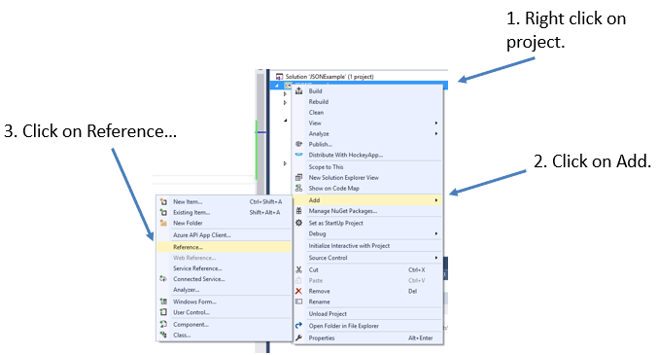
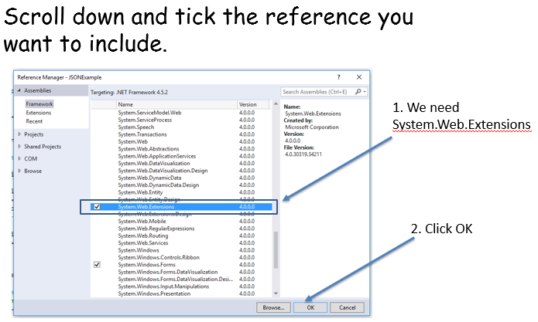

Serialising data is simple with JSON. First Serializer will have to be defined in the RemoteFlightController class like so:
To create an instance of the object we are serialising (writing the data) in a method this is how it’s done:

To create an instance of the object we are deserialize (reading the data) in a method this is how it’s done:

References

Lecture Slides
https://www.w3schools.com/js/js_json_intro.asp - accessed 18/4/18
http://json.org/example.html - accessed 18/4/18
https://docs.microsoft.com/en-us/dotnet/framework/wcf/feature-details/stand-alone-json-serialization - accessed 18/4/18

